**SECRET CODE ENABLED SECURE COMMUNICATION USING RF COMMUNICATION**

Communication between any two devices is very important for data exchange. The aim of this project is to establish communication path between two microcontrollers for data exchange. The communication can be done using wires but if the distance between two microcontrollers is too large, cabling cost increases. Thus, we have to switch to other better alternatives. The next and efficient choice is using wireless communication.

This project uses wireless concept RF. The advantage of RF is fast communication. Same configuration will be arranged at both the ends. RF transmitter and receiver will be fixed at both the ends. When a microcontroller wishes to send data to the other, it enables RF transmitter at its end and sends the data.

At the other end, RF receiver receives the data and passes the data to the microcontroller. The microcontroller continuously checks and decides to enable the transmitter or receiver to send or receive the data. The data sent and received can be seen on LCD at both the ends.

This project uses regulated 5V, 500mA power supply. Unregulated 12V DC is used for relay. 7805 three terminal voltage regulator is used for voltage regulation. Bridge type full wave rectifier is used to rectify the ac out put of secondary of 230/12V step down transformer.

**SOFTWARE AND HARDWARE TOOLS:**

**Software Tools:**

1. MPLAB
2. Orcad.
3. Proteus

**Hardware Tools:**

1. Microcontroller PIC16F877A
2. LCD
3. RF TRANSMITTER
4. KEYPAD
5. RF RECIEVER

**BLOCK DIAGRAM**

**TRANSMITTER:**

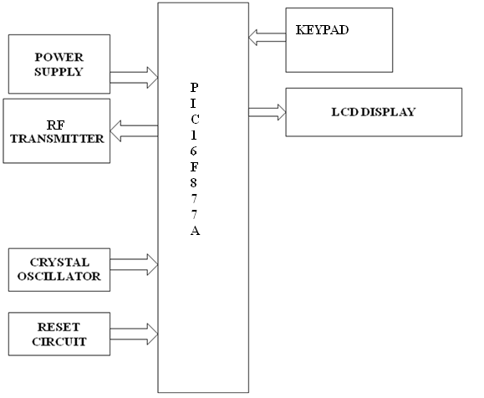

**RECIEVER:**

